Cootamundra Bowls 

Newsletter

21st Edition

November 2017

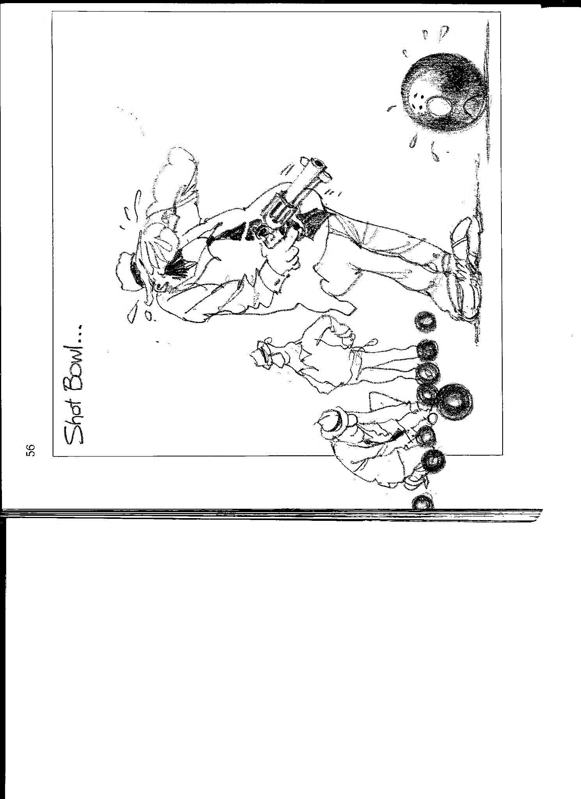

**Shot bowl:**

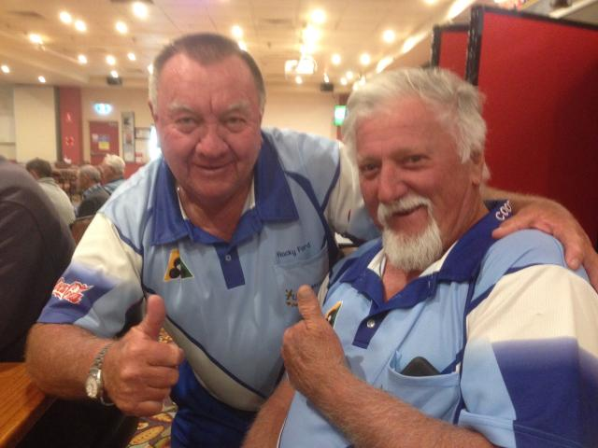

**2017 Men’s Club Champions:**

**Major Singles:** Roman Bondaruk.

**Minor Singles:** Mick Ryan.

**Major Pairs:** Peter Deacon & Don O’Neil

**Minor Pairs:** Wally Chater & Terry Smith

**Triples:** Anthony Wilson, Peter Deacon & Jim Deacon.

**Fours:** Denis O’Brien, Wally Chater, Alan Small &

John Harriott.

**Major/Minor:** Wayne Ford & Jim White.

**Mixed Pairs:** Freda Hambrook & Neil Webb

**Presentation Night Men’s and Ladies 16th December, Club Auditorium.**

Auditorium doors open 6.30pm.

Names and payment at front counter of club.

Numbers are needed by end of November so catering can be arranged.

Cost: $20.00 each Member and partner. $30.00 each non-members.

**2017 Major / Minor Champions:**

Wayne (Rocky) Ford and Jim White secured the Major/Minor title with some great bowls. Their opposition Rod Ball and Graeme Snape put up a gallant fight but in the end Rocky and Jim come home too strong winning

23-13. Great effort Rocky and Jim.

|  |
| --- |
|  |

**Birthday wishes in November:**

Mick Ryan, Denis O’Brien, Keith Hampton, Kim Roberts, Peter Deacon, Bruce Gillies, Nigel Buttriss, Marilyn Allen, Joan Cummins Sara Lopez, Sue Murray.

**Birthday wishes in December**

Adam New, Geoff Manwaring, Paul Calmanovici, Don O’Neil, Emily Cosgrove, Graeme Dennis,

Judy Paul, Oscar Lopez.

**Three player pairs:**

Rain washes out Saturday’s play in the novelty three player Pairs tournament. Saturday’s games were added to Sunday’s games bring the total to seven games starting at 9.15am, where all eight teams won at least two games in the five end format. Winners for the day with a magnificent seven wins from seven games were Rob Hillier, Wayne Watmore and Frog Roberts. Second place went to Steve Stanton, Wally Chater and Bob New with five wins and in third place we had Steve Leggett, Alan Small and Jim White with four wins.

The day and the format was an outstanding success and all indications are this format will be played again in 2018.

Mixed Pairs was the final championship for 2017. Due to illness and medical procedures there were withdrawals and subs used to complete this championship.

The final was played between Lorraine Evelyn & Wally Chater with their opposition being Freda Hambrook & Neil Webb. This was a close encounter as a final should be but in the end Freda & Neil claimed the 2017 mixed title 19-14.

**2017 Ladies Club Champions:**

**Major Singles:** Wendy Deacon

**Minor Singles:** Colleen Goode

**Pairs:** Sara Lopez & Lynn Fisher

**Triples:** Bev Black, Marilyn Allan

& Robyn Snape

Lady bowlers at Cootamundra station ready for departure for their annual R&R trip to Sydney where this year they viewed Carol King musical, the added bonus was a few days away from their other half. The 16 ladies had a sensational few days. Thursday a leisurely ferry trip from the Sydney to Parramatta where all took in the scenery.

The train guard was over heard saying thank god they are off the train, we may have a bit of peace and quiet. All the ladies intend to make the trip again next year where the show they see will be Jersey Boys. The ladies would like to thank Lynn Fisher for all the time and effort she puts into organising their yearly trips.



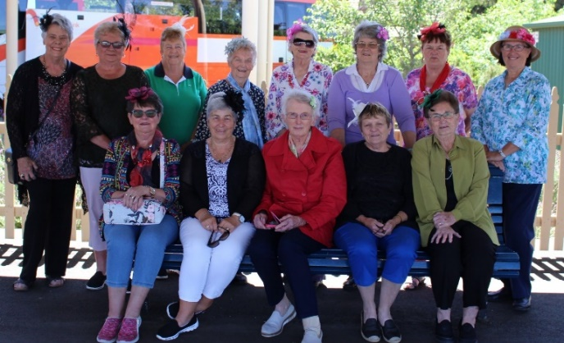

The Annual hospital charity day went off without a hitch where 36 bowlers took to the green. Fortunately the rain held off long enough to complete the days play. First place was awarded to Jacob & Mark (misplaced their last names sorry fellas) and Steve Stanton & Geoff Hillier playing one game each, while Elenore Armstrong, Jo Leggett and Eddy Jarrett collected second place. Both first and second places were drawn out of a hat. Barman Clancy and Lynn Fisher were the lucky winners of the two fruit box raffles and Patty O’Brien took the prestigious spider prize home.

Judging by the laughter and banter around the green all who participated enjoyed the day. A total of $800 was the amount raised for this worthy community cause.

Well done to all who supported the day.

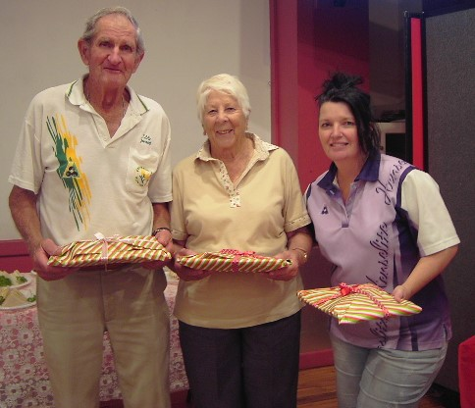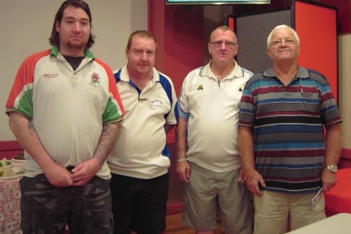

Eddy, Elenore & Jo

Jacob, Mark, Steve & Geoff



A reminder to all that the green will be closed as of 27th November 2017 for approximately six weeks. The green is having its annual renovation. Anyone wishing to give a hand with the renovation please contact a Committee member.

Cootamundra Ex-services Maestro Singles will commence Tuesday 16th January 2018 all being well. There is a sheet on the bowls table for your entry.

Don’t forget to keep Good Friday vacant for our annual Arthur Ryan Mixed Pairs and the annual Easter Men’s Triples held Easter Saturday 31st March & 1st April 2018.

**Don’t miss this great weekend of bowls!!**

Wishing all who read this newsletter a very happy Christmas and a safe and prosperous new year.

**The Indian with One Testicle**

There once was an Indian who had only one testicle and whose given name was 'Onestone'. He hated that name and asked everyone not to call him Onestone. After years and years of torment, Onestone finally cracked and said,' if anyone calls me Onestone again I will kill them!' The word got around and nobody called him that any more. Then one day a young woman named **Blue Bird** forgot and said, 'Good morning, Onestone.' He jumped up, grabbed her and took her deep into the forest where he made love to her all day and all night. He made love to her all the next day, until **Blue Bird** died from exhaustion.

The word got around that Onestone meant what he promised he would do. Years went by and no one dared call him by his given name until a woman named **Yellow Bird** returned to the village after being away. **Yellow Bird**, who was **Blue Bird's** cousin, was overjoyed when she saw Onestone. She hugged him and said, 'Good to see you, Onestone.' Onestone grabbed her, took her deep into the forest, then he made love to her all day, made love to her all night, made love to her all the next day, made love to her all the next night, but **Yellow Bird** wouldn't die!   
**Why???**

Everyone knows. **You can't kill Two Birds with OneStone!!!**

Your feedback would be greatly appreciated.

If you would like to contribute to this newsletter Contact.

Greg Fisher: Phone: 0416 061049

Email: grumpy[fisher@bigpond.com](mailto:fisher@bigpond.com).

If you wish to unsubscribe from this newsletter, please let Grumpy know.